**25 Jan 2019** **The Weekly Bulletin of Rotary Club of Kathmandu Mid-Town** **bc-18.1/019**

|  |
| --- |
| C:\Users\Public\Documents\RIP T1819_EN.png |

District: 3292 Web:www.rotarymidtown.org.np Club Id: 26776

**JANUARY IS VOCATIONAL SERVICE MONTH**

**Vocational Service Month** is an opportunity to begin year-long vocational service activities, ranging from Rotary discussions to awards to community projects. Discussions on vocational service can lead to projects that not only develop the ethical consciousness and vocational skills of Rotarians but also the talents within their communities.

Some suggested activities to undertake during this Month:

Devote a meeting to examine and create an awareness including The Four-Way Test and The Declaration of Rotarians in Business and Professions;

Introduce a "mini-classifications talk" series in which each member gives a five-minute talk on his or her vocation. The purpose of these talks is to promote vocational awareness among Rotarians and help them recognize the worthiness of all useful occupations;

Present a vocational award to someone in the community who has exemplified outstanding professional achievement while maintaining very high ethical standards. Promote the presentation within the community, and consider making it an annual October event;

Invite experts to give a presentation on the vocational needs of the community and develop projects in response to those needs.

Encourage club members to put their vocational skills to work as a Rotary Volunteer.

**Club’s Weekly Meeting # 1473 held on Friday 18 Jan 2019**

Guest speaker Dr Birat Sinha talked on current scenario of mental health in the country. Mental health issue, though hidden, is a pressing issue. It is not discussed in public because of stigma. It was only of late that a national mental health survey was carried out. Rotary Clubs could help people by organizing awareness programs on this issue.

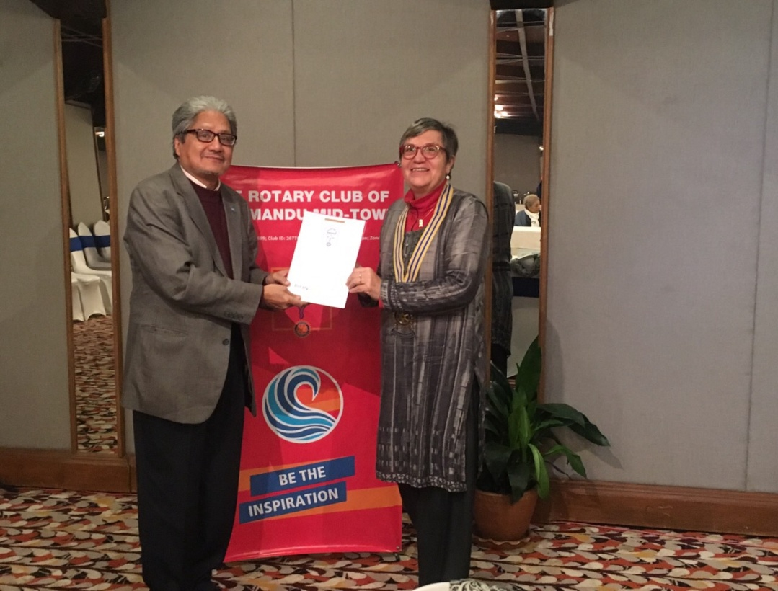

President Jo handing over a certificate of appreciation to the guest speaker

*Photo courtesy: Rtn Shyam R Thapalia*.

**Club Meeting # 1474 Friday 25 Jan**

Ms Anita Rijal and Mr Stephen Kovats will be our guest speakers. They will jointly talk to share what they have been doing in Nepal for training and helping young innovators to develop successful businesses.

Ms Anita Rijal, after studying Global Health and Child Development at Tufts University, USA, for her undergraduate degree, worked with the Somerville Public School System and then with the AFT children’s health and well-being program. Back to Nepal, she is currently a Program officer at Nepal Communitere, an Innovation hub and Resource Center to strengthen Nepali innovation projects and build them into successful businesses.

Mr Stephen Kovats is the founding co-director of an agency for open culture and critical transformation, a Berlin based INGO promoting/developing the use of open source resources, tools and platforms primarily for critical post-conflict/disaster transformation. The agency developed ASKotec (Access to Skills and Knowledge open tech emergency case) a mobile technical platform deployable anywhere regardless of access to electricity/internet. ASKotec was introduced to Nepal at the Kathmandu Mini Maker Fair in 2018.

**RID 3292 District Conference 2019:**



**11th District Conference is going to be held in Butwal, Gandaki Province**

**22 - 24 February 2019.**

Registration fee (Rs) Upto 31 Dec 2018 Jan 1-Feb 15 2019 Spot Registration

Rotarian/Guest 6,000 6,500 7,000

Rotarian with non-Rotarian

spouse 11,000 12,000 13,000

Rotaract/Interact/RCC 3,000 3,500

100% Registration by any club Rs 5,500 per person (Deadline: 31 Jan 2019)

Early-bird Registration (11th District Conference at Butwal) Rs 5,500 (Rotarian)

and Rs 11,000 (couple)

For more information, contact:

Rom Sharma (Conference Office Secretary); districtconference019@gmail.com

Tanka P. Pokharel (Registration Sub-Committee Chair): Pokhareltp@gmail.com; mobile: 9857021325

**Gift of Sight Eye Camp in Hetauda:**

President Jo along with a group of Mid-Towners visited Hetauda where Gift Of Sight Eye Camp was being held on 7-9 Jan 2019 in coordination with RC Hetauda and supported by RC Garden City, Singapore. Altogether 171 patients were provided free Cataract surgery with Intra Ocular Lens Implant.

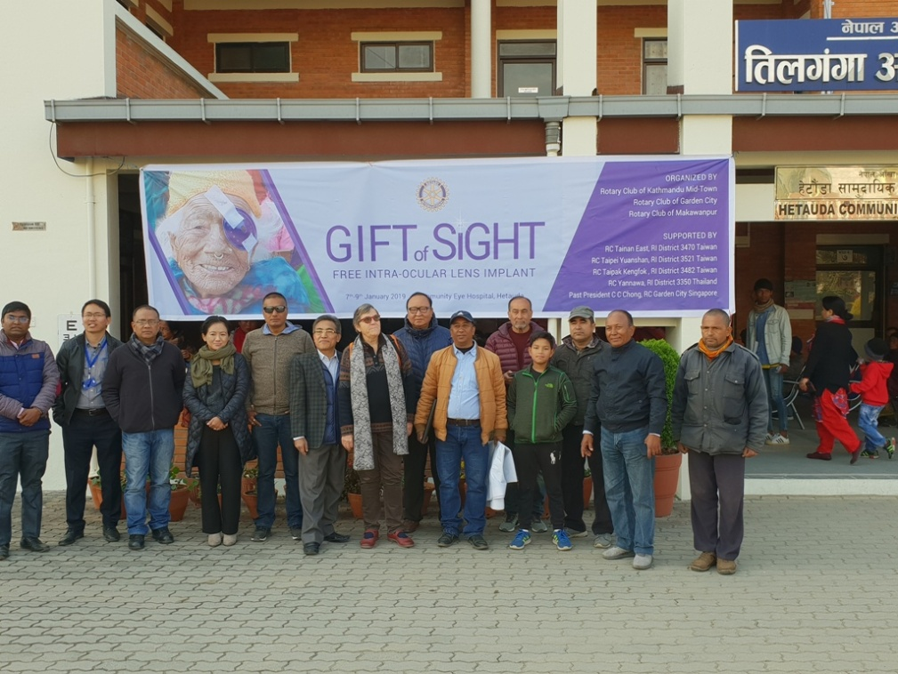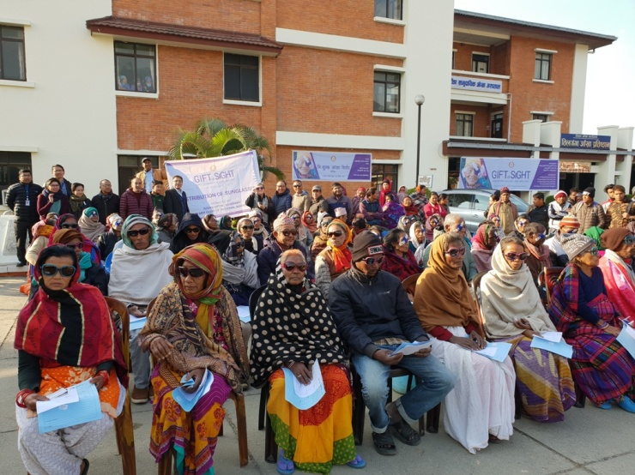

President Jo and other Mid-Towners attended the meeting of the Rotary Club of Makawanpur and exchanged flags.

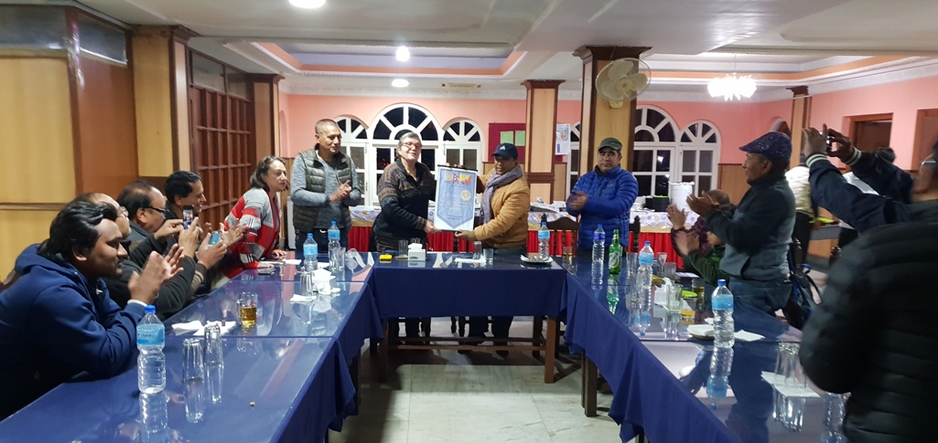

*- Photo courtesy: PP Ajaya Sthapit*

**PP Council Meeting:**

A Past Presidents' Council meeting was held on Monday 21 January 2019 at Nanglo Restaurant, for discussion mainly on addressing future Club leadership plan, membership development and engagement.

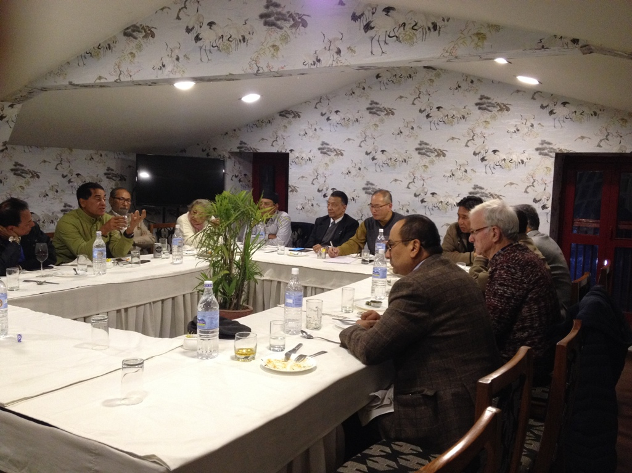

**Do you Know** **?**

Robots that are transforming the global elder care industry.

How do we take care of the old? Do we need to take the help of machines to move, moni tor and talk to them? Japan is funding the development of elder care robots to fill a projected shortfall of 380,000 specialised workers by 2025.

Companies are also eyeing a potentially lucrative export industry of supplying robots to places like Germany, China and Italy, which could face similar demographic challenges.

*Read more on https://economictimes.indiatimes.com/news/science*

**A THOUGHT FOR THE DAY**

Men build too many walls and not enough bridges.

-Isaac Newton, physicist, mathematician, and philosopher (25 Dec 1642-1727)

*Courtesy: Rtn Dr Isabella Khadka*

On Lighter Side:

Little Johnny's kindergarten class was on a field trip to their local police station where they saw pictures, tacked to a bulletin board, of the 10 most wanted criminals.

One of the youngsters pointed to a picture and asked if it really was the photo of a wanted person.

"Yes," said the policeman.

"The detectives want very badly to capture him."

Little Johnny asked, "Why didn't you keep him when you took his picture?"

Rotary emphasizes the dignity of every vocation and the worth of every calling. Remember

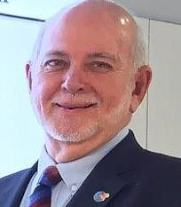

that the four founding members included no doctors or peacemakers — just an attorney, a

mining engineer, a coal dealer, and a printer. From the beginning, the diversity of those

vocations gave Rotary a special strength. And that diversity is reflected in our classification

system, which aims to ensure that each club represents the full range of businesses and

professions that serve each community.

**RI President Barry Rassin**

Please send information on club activities, progress reviews on service projects, relevant photos etc to:

BC Editor: RR Shrestha email: rryesrr@gmail.com

## 25 Jan 2019 The Weekly Bulletin of Rotary Club of Kathmandu Mid-Town bc-18.1/019